# ECZEMA

**SYMPTOMS:**

**Atopic dermatitis (eczema) is a condition that causes dry, itchy and inflamed skin**. It's common in young children but can occur at any age. Atopic dermatitis is long lasting (chronic) and tends to flare sometimes. It can be irritating but it's not contagious.

## TREATMENT:

There is currently no cure for eczema. Treatment for the condition aims to heal the affected skin and prevent flares of symptoms. Doctors will suggest a

treatment plan based on an individual’s age, symptoms, and current state of health.

# PRURITUS

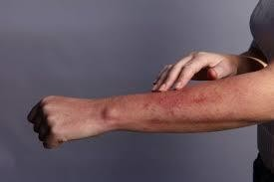

**SYMPTOMS:**

**Itchy skin** is an uncomfortable, irritating sensation that makes you want to scratch. Also known as pruritus (proo-RIE-tus), itchy skin is often caused by dry skin. It's common in older adults, as skin tends to become drier with age.

## TREATMENT:

* Antihistamines.
* Topical steroids or oral steroids.
* Immunosuppressant medications, such as cyclosporine A.

# HIVES

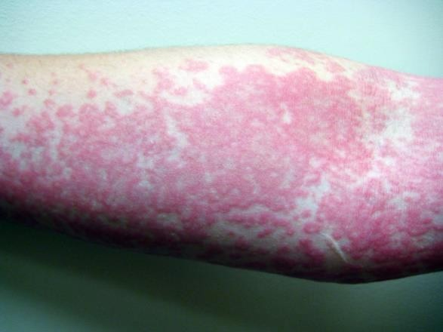

## SYMPTOMS:

**It causes itchy welts that may be triggered by foods, medications or other substances**. Changes in color of the affected area might be less visible on brown or Black skin. Hives — also called urticaria (ur-tih-KAR-e-uh) — is a skin reaction that causes itchy welts.

## TREATMENT:

1. Avoid triggers. ...
2. Use an anti-itch drug available without a prescription. ...
3. Apply cold. ...
4. Take a comfortably cool bath. ...
5. Wear loose, smooth-textured cotton clothing. ...
6. Protect your skin from the sun.

# RED BUMPS

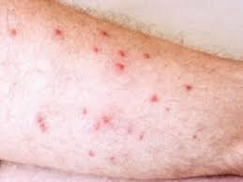

## SYMPTOMS:

There are several possible causes for red dots on the skin,

including **heat rash, KP, contact dermatitis, and atopic dermatitis**. Red dots on the skin may also occur due to more serious conditions, such as a viral or bacterial infection.

## TREATMENT:

**avoiding rubbing or scratching the skin rash**. applying a cold compress to relieve swelling and pain. applying aloe vera to the affected skin to reduce swelling and soothe pain. using moisturizers to hydrate dry, flaky skin.

# ANGIOEDEMA

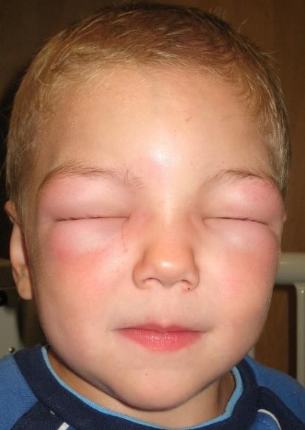

## SYMPTOMS:

* Abdominal cramping.
* Breathing difficulty.
* Swollen eyes and mouth.
* Swollen lining of the eyes (chemosis)

## TREATMENT:

* + Medicines to ease swelling and inflammation, like [antihistamines](https://www.webmd.com/allergies/antihistamines-for-allergies) and oral corticosteroids.
  + Drugs to slow down your immune system if antihistamines and corticosteroids don’t work.
  + Blood protein controllers if you have hereditary angioedema.

# PSORIASIS

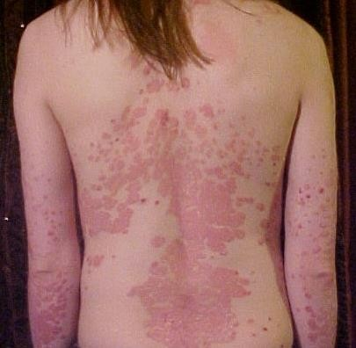

## SYMPTOMS:

Psoriasis is **a skin disease that causes a rash with itchy, scaly patches, most commonly on the knees, elbows, trunk and scalp**. Psoriasis is a common, long-term (chronic) disease with no cure. It can be painful, interfere with sleep and make it hard to concentrate.

## TREATMENT:

Psoriasis treatments aim to stop skin cells from growing so quickly and to remove scales. Options include creams and ointments (topical therapy), light therapy (phototherapy), and oral or injected medications.

# ACNE

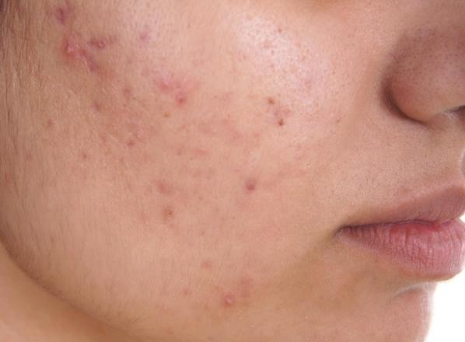

## SYMPTOMS:

* Whiteheads (closed plugged pores)
* Blackheads (open plugged pores)
* Small red, tender bumps (papules)
* Pimples (pustules), which are papules with pus at their tips.
* Large, solid, painful lumps under the skin (nodules)
* Painful, pus-filled lumps under the skin (cystic lesions)

## TREATMENT:

Usually the first choice for treating acne is a **tetracycline (minocycline, doxycycline) or a macrolide (erythromycin, azithromycin)**. A macrolide might be an option for people who can't take tetracyclines, including pregnant women and children under 8 years old.

# VITILIGO

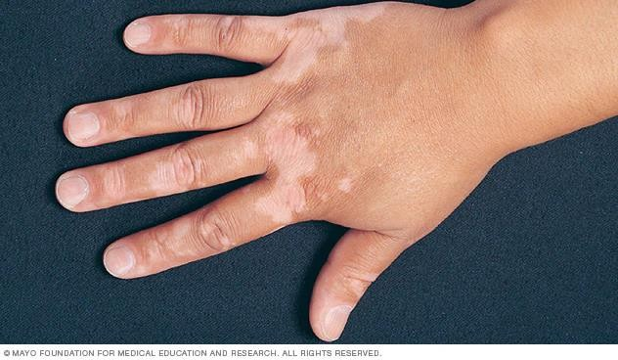

## SYMPTOMS:

The main symptom of vitiligo is loss of natural color or pigment, called depigmentation. The depigmented patches can appear anywhere on your body and can affect: Skin, which develops milky-white patches, usually on the hands, feet, arms, and face. However, the patches can appear anywhere.

## TREATMENT:

Treatment of Vitiligo Most treatments for vitiligo focus on stopping the immune system from destroying the melanocytes and improving the skin’s appearance. In most cases, the goals of your treatment are to: Slow or stop the disease from progressing. Encourage the regrowth of melanocytes

# BRUISES

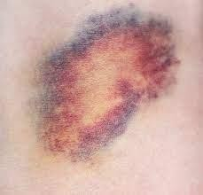

## SYMPTOMS:

Bruises form when blood pools under the skin after an injury.

Bruises start **black and blue, brownish or purple**. They change color as they fade (often without treatment). Older people are more prone to bruising.

## TREATMENT:

1. Rest the bruised area, if possible.
2. Ice the bruise with an ice pack wrapped in a towel. Leave it in place for 10 to 20 minutes. Repeat several times a day for a day or two as needed.
3. Compress the bruised area if it is swelling, using an elastic bandage. Don't make it too tight.
4. Elevate the injured area.

# HERPES ZOSTER

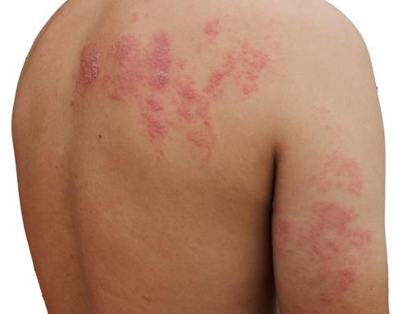 **SYMPTOMS:**

Shingles is **a painful rash that develops on one side of the face or body**. The rash consists of blisters that typically scab over in 7 to 10 days and fully clears up within 2 to 4 weeks. Before the rash appears, people often have pain, itching, or tingling in the area where it will develop.

## TREATMENT:

Several antiviral medicines—**acyclovir, valacyclovir, and famciclovir**— are available to treat shingles and shorten the length and severity of the illness. These medicines are most effective if you start taking them as soon as possible after the rash appears.